YEAR 3 -YEAR 5 WORKBOOK

Good byes and New Beginnings

Support for those moving year groups during lockdown

In Part 1 of this workbook we look at some of the different ways you might have been affected by this sudden change, and how you might be feeling about it all.

In Part 2 we are also going to look at some ways that you can get some sense of an ending, and help you get ready for the next year group

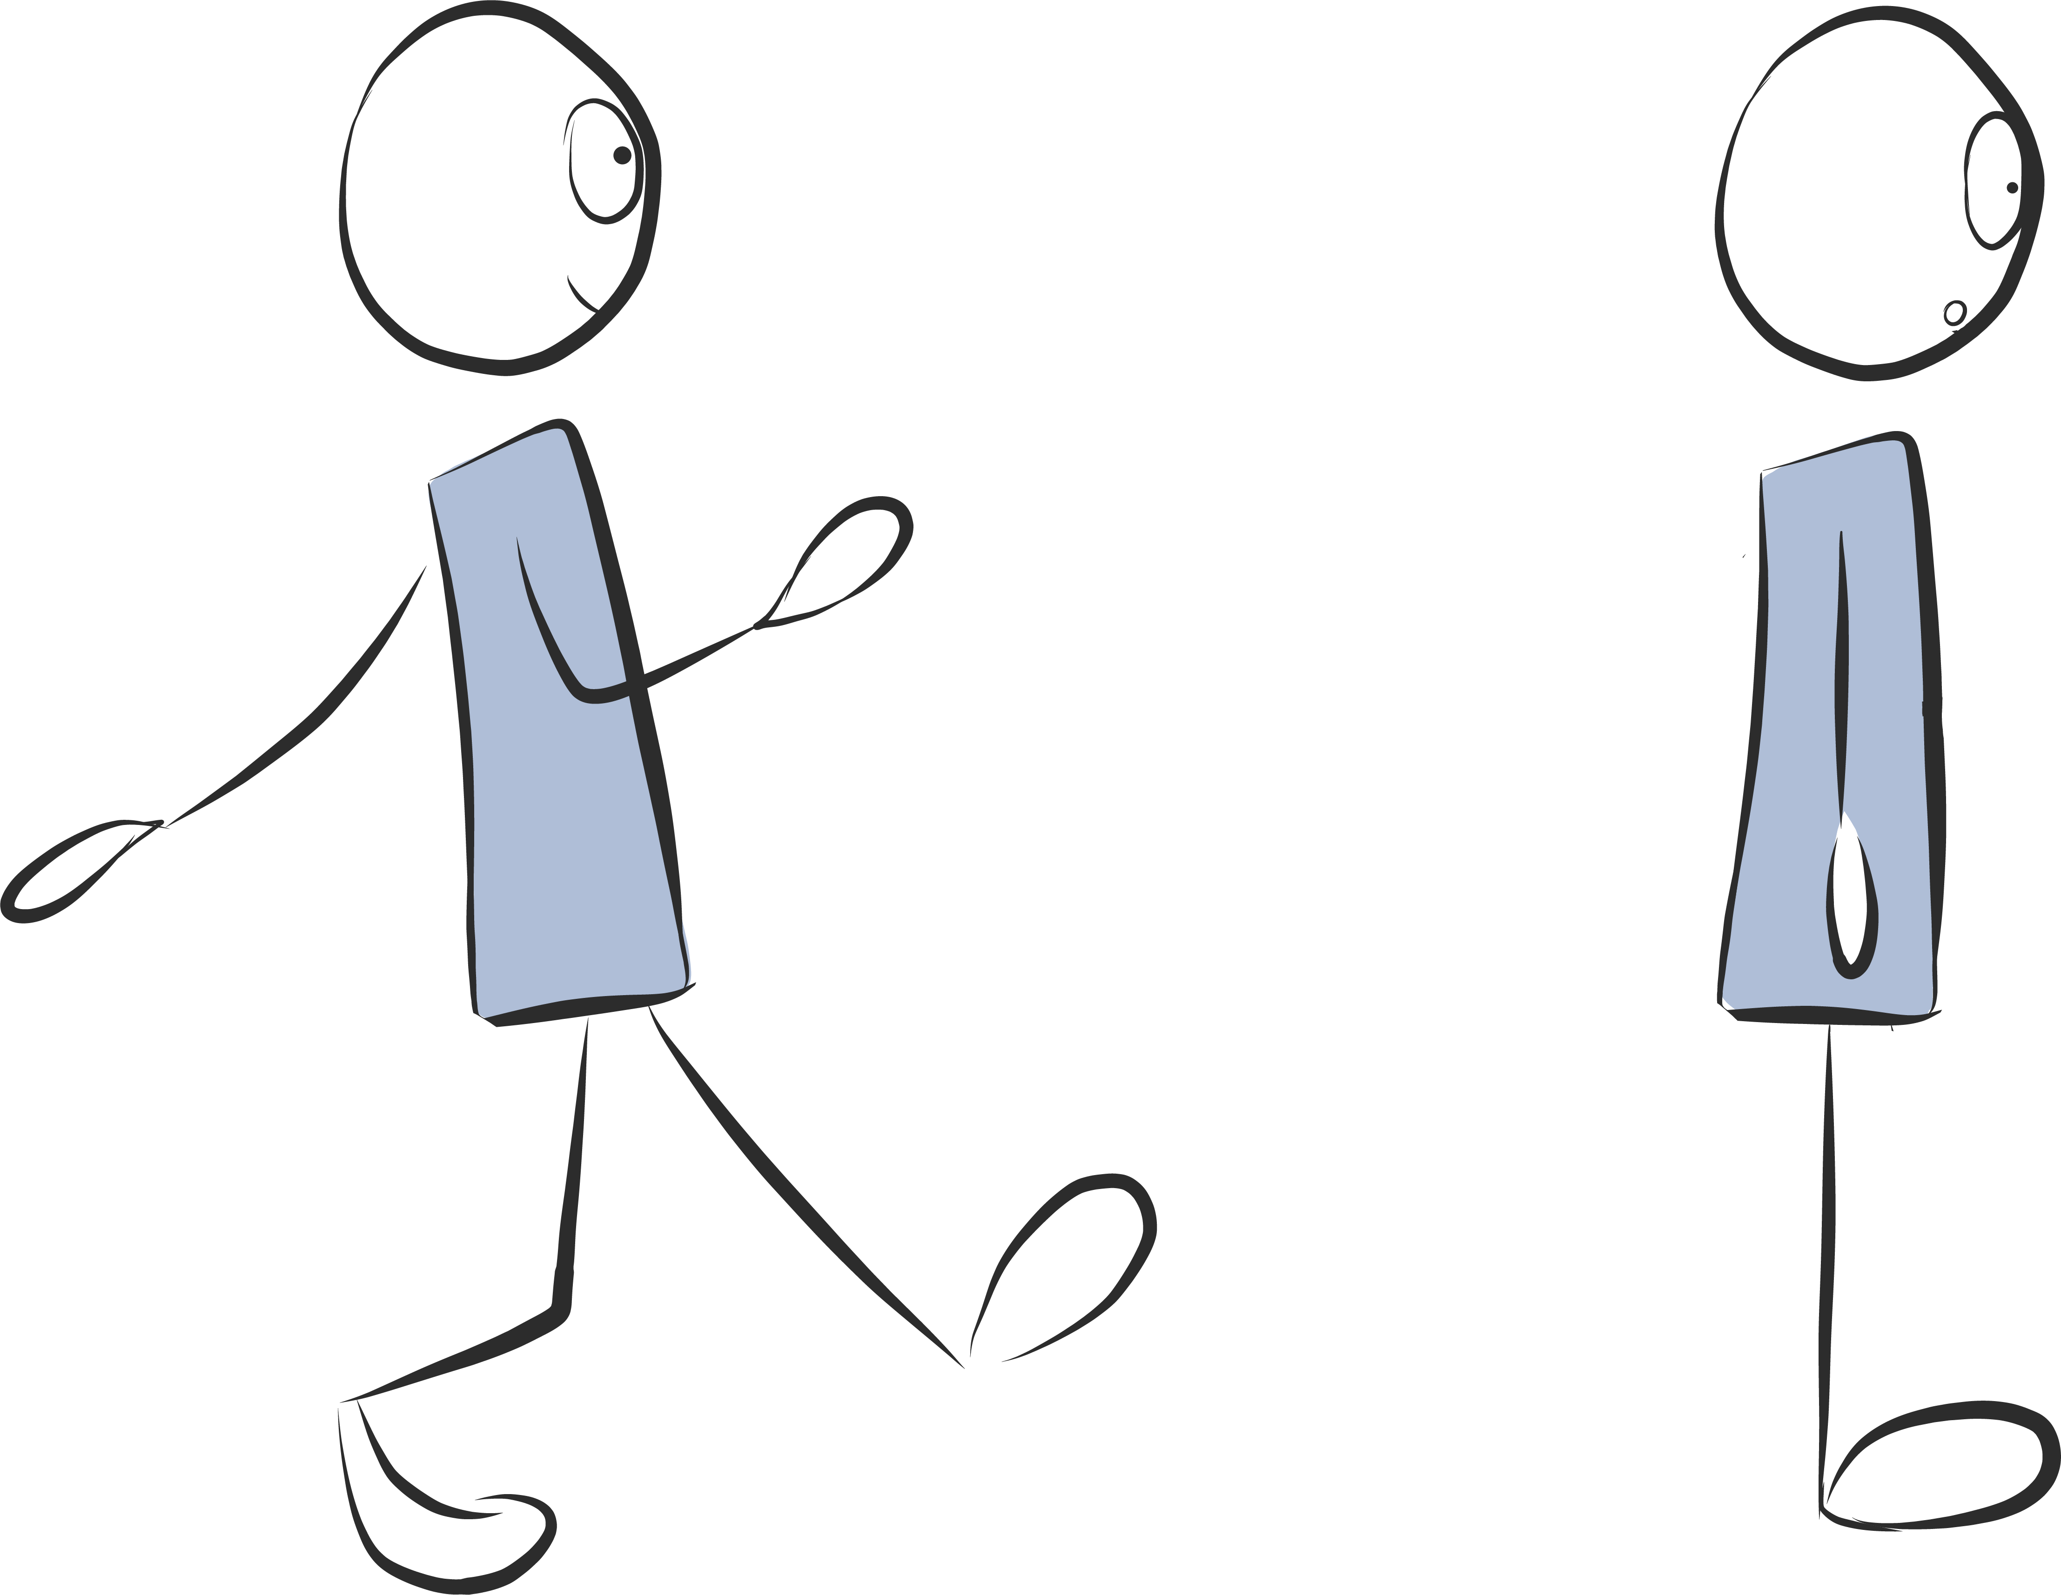
SCHOOL AND OUT & ABOUT LIFE

STOPPED

PART 1 – SO WHAT HAPPENED…?

Just before lockdown started in late March 2020, your were busy learning, having fun, studying and …then suddenly there was no more school, no more tests and everything you thought was going to happen over the next three months evaporated into thin air.

How did you feel about it?

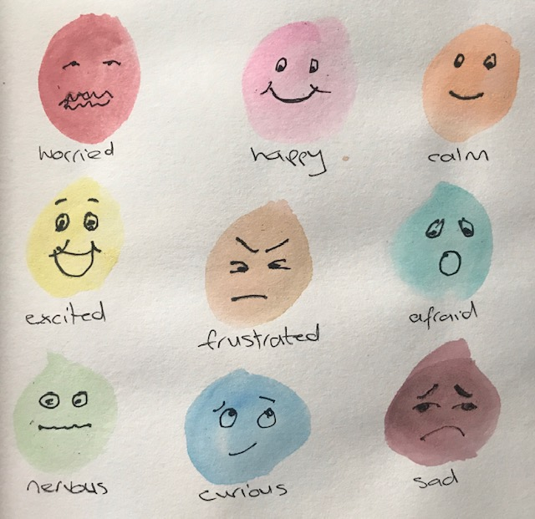
Exercise: Use this box to write or draw how it made you feel.

MISSING OUT

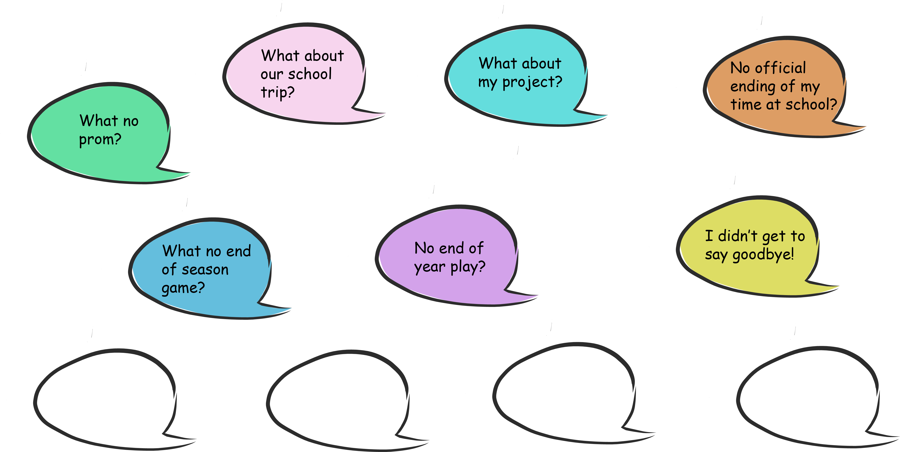
Because school and all your regular activities came to a sudden stop, and you did not get to complete the school year. Exercise: What are some of the things that you have missed out on?

Fill in your own thoughts in the bubbles below

LOSS – SADNESS

It is important to acknowledge the loss of things that were important to you. Even if there is nothing you can do about situations, noticing your feelings is key to being able to accept what has happened and move on.

Exercise: 2 things I wish could have happened that didn’t:

1.

2.

3.

PART 2 – MOVING FORWARD

How to tap into your inner super powers! By learning to do things for your self, like getting dressed, helping out at home this builds confidence and feelings of “yes I can do it”

What things can you do every day that helps you feel awesome

1. Make your bed

2. Get dressed on your own

3. Put your things away

4. Go for a fun walk for 15mins or more

5. Feed your pet

6. Take the rubbish out to the bin

7. Do breathing where you can feel your body moving, your chest getting bigger, your tummy moving, then chose to do it gently

8. Help make breakfast or lunch or dinner!

9. Set the table for dinner

10. Give your parent/carer/family member a big hug

Pick a four and write them in the circles.
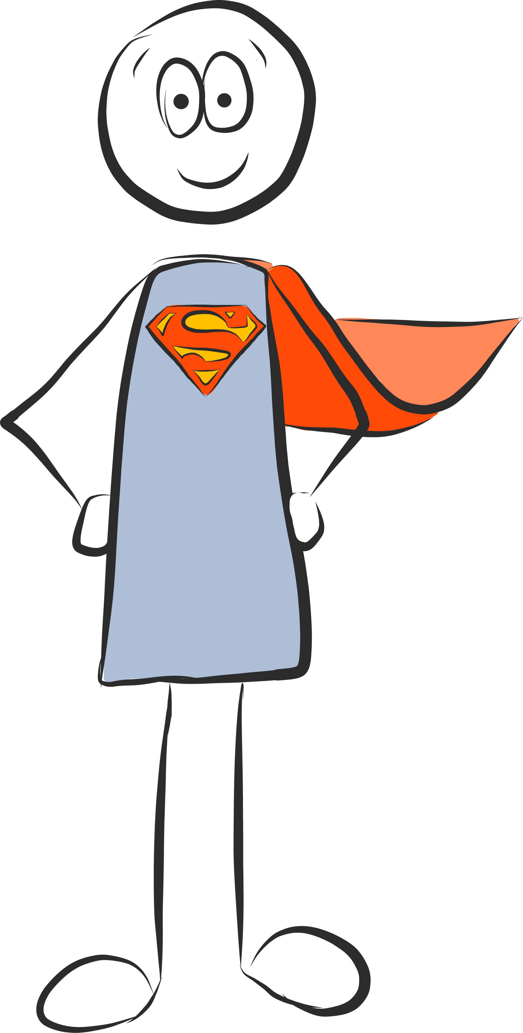

SELF

What have you learned about yourself from this situation?

Given the sudden unusual nature of Covid-19 what you have learned, about yourself and the world you live in.
Times of change or challenge can sometimes bring out qualities from within us that come to the fore and show a different side to us. What did you learn about yourself?
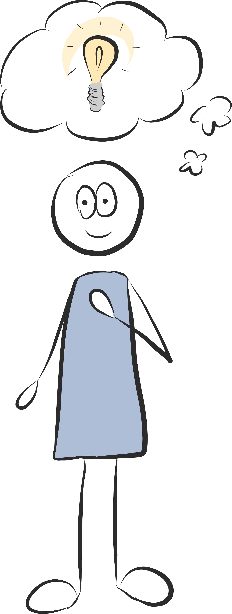

3 things I have learnt about myself…

1.

2.

3.

Letter to my current teacher
Tell your teacher the things you enjoyed this year at school your favourite topic, books, games you can draw a picture too of something you love about school

Letter to my new teacher
Your new teacher will love to know some things about you that will help them get to know you tell your new teacher some things about you, who is in your family, your favourite book character, best thing you did during lockdown, the thing you are looking forward to for the next school year. You can draw a picture too.

To my new teacher - All about me
Chose from the below adjectives or chose your own to
describe you personality qualities

Caring playful determined honest kind funny hard working

Resilient enthusiastic ambitious motivated self belief trustworthy

Dependable excitable
I am…

Things I am looking forward to draw or write

What skills can you gain before September 2020

What did you learn to do around the house?
Can you tie your shoelace?
Can you tell the time?
Can you make your bed – without being asked?
Can you plan and make a meal for the family?
Can you make your own breakfast?
Can you make your own lunch?
Can you bake a cake/ muffins/ biscuits?
Can you vacuum?
Can you clean your plate away after eating?
Can you sweep the floor?
Can you exercise for 30mins every day?
Can you do things that make your body feel calm?

